Title : A holistic approach of Comperative Analysis of Independent Component Analysis and Principal Component Analysis of Electromyographic Movement Detection using Machine Learning and Deep Neural Network

About The Dataset

Deep Learning Architecture

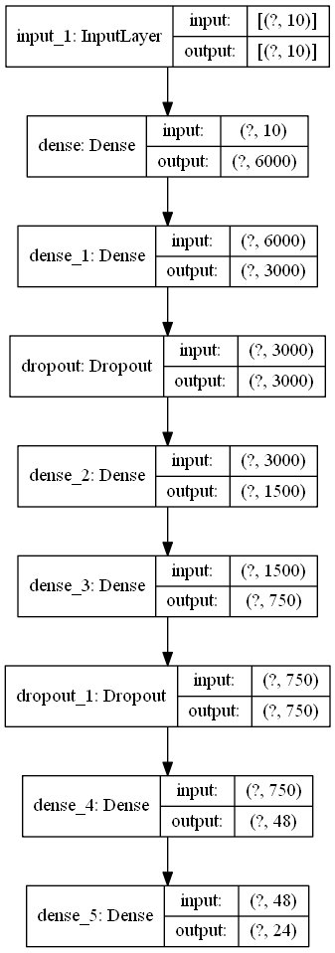

Feature Selection

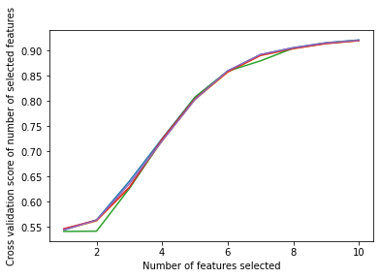

**Figure: How Accuracy is Increasing by Selecting each Features (Wrapper Method: RFE Feature Selection)**

|  |  |
| --- | --- |
| **Features** | **Boruta Feature Selection** |
| Emg 1 | True |
| Emg 2 | True |
| Emg 3 | True |
| Emg 4 | True |
| Emg 5 | True |
| Emg 6 | True |
| Emg 7 | True |
| Emg 8 | True |
| Emg 9 | True |
| Emg 10 | True |

**Table: Optimal Number of Feature Selected by Boruta Feature Selection (Wrapper Method)**

|  |  |
| --- | --- |
|  | Least Important Feature |
| Subject 1 | Emg6 |
| Subject 2 | Emg6 |
| Subject 3 | Emg5 |
| Subject 4 | Emg5 |
| Subject 5 | Emg1 |
| Subject 6 | Emg1 |
| Subject 7 | Emg1 |
| Subject 8 | Emg1 |
| Subject 9 | Emg5 |
| Subject 10 | Emg1 |

**Table: Least Important Feature Selected by ANOVA + Random Forrest Feature Importance**